Project Report – Movie Ticket Booking System

Introduction
The Movie Ticket Booking System is a Python-based console application designed to replicate a simple cinema booking experience.
It allows users to select movies, view seat layouts, book and cancel seats, and generate a detailed booking receipt. The system
uses a 5x5 seat grid where each seat is labeled using row letters A–E and column numbers 1–5. Seats are visually represented using
“O” for available and “X” for booked. This project highlights important Python concepts such as loops, conditionals, functions,
lists, dictionaries, input validation, and modular programming. It is ideal for students and beginners aiming to understand how programming logic can be applied to real-world applications.

System Design
The system follows a modular architecture, with each functionality managed by a dedicated function. Movie details are stored in a
dictionary that contains IDs, names, and ticket prices. Seat data is handled using a nested list (5x5 matrix), enabling efficient
storage and modification. The program maintains a list of booked seats along with corresponding prices to generate receipts. It
validates all user inputs—whether selecting movies or entering seat labels—to ensure smooth and error-free interactions. The
design ensures prevention of double-booking and proper handling of cancellations. This structure makes the code clean, maintainable, and easy to expand in the future.

Key Functions Used
The system uses several important functions:
- display_movies(): Shows all movies and prices.
- display_seats(): Displays the current seat matrix with labels.
- book_seat(): Books a specific seat after checking availability.
- cancel_seat(): Cancels a booked seat and updates data.
- print_receipt(): Generates a receipt with booked seats and total cost.
- main(): Controls overall program flow and user interaction.
Each function performs a specific task, improving structure and readability.

Workflow
The user begins by selecting a movie from the displayed list. The system then shows the seat layout and allows the user to book or
cancel seats. All seat inputs are validated to ensure they follow the correct format and exist within the grid. Booked seats are
tracked and updated in real time. Upon exiting, the system requests the customer’s name and prepares a detailed receipt showing the movie selected, booked seats, and the total amount payable.

Test cases
- Selecting a movie.
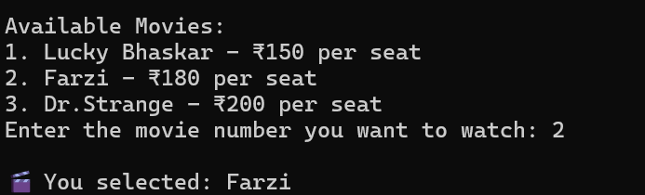

- Booking seats:
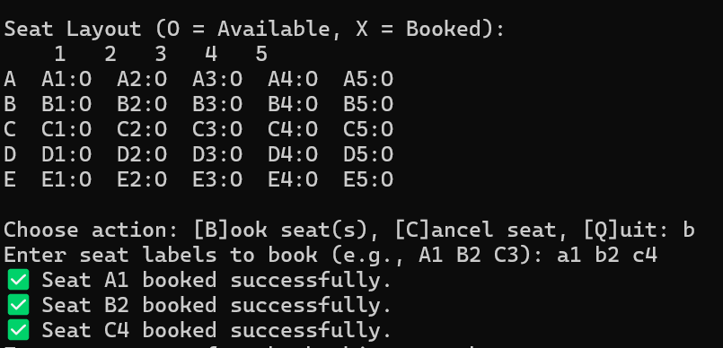

- Choosing wrong seat labels:
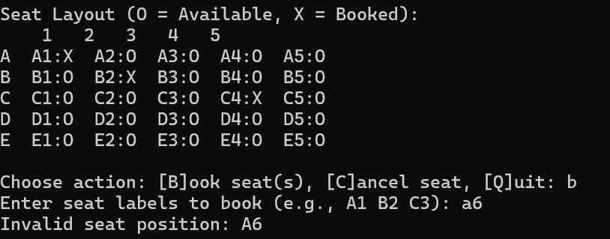

- Cancelling a seat which is not booked yet.
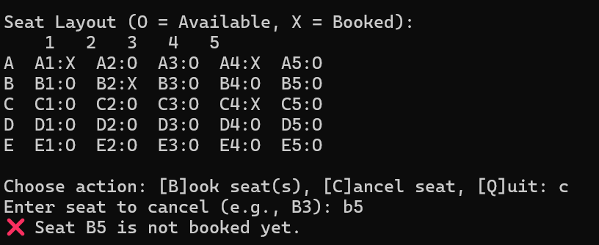

- Cancelling a seat which doesn’t exist.
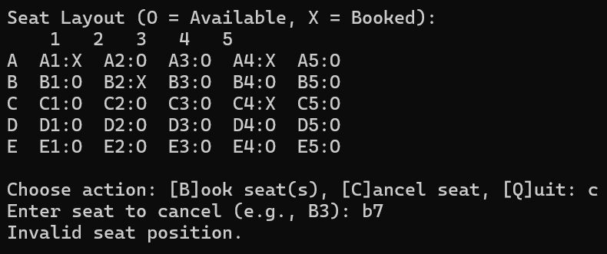

- Generating booking receipt.
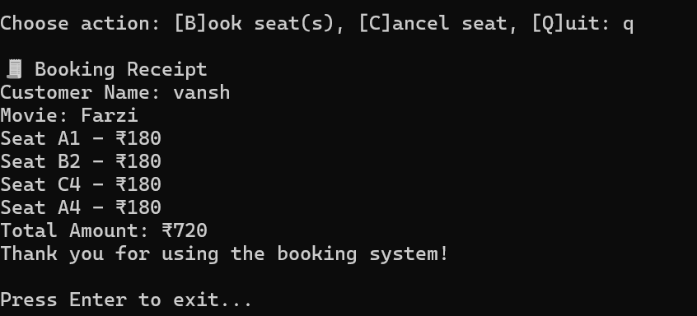

Conclusion
The Movie Ticket Booking System is an effective demonstration of Python fundamentals applied to a practical task. It highlights the
importance of modular programming, data structures, and user interaction handling. The project can be enhanced further by adding
graphical interfaces, database connectivity, multiple showtimes, or user login systems. Overall, it serves as a solid foundation for building more advanced applications in Python.

